Korme kedir

Arizona State University

IFT 458/598 – Middleware Programming & Database Security

Instructor: Danish Sthapit

Module 3: Data Exchange and Data Formats

02/12/2023

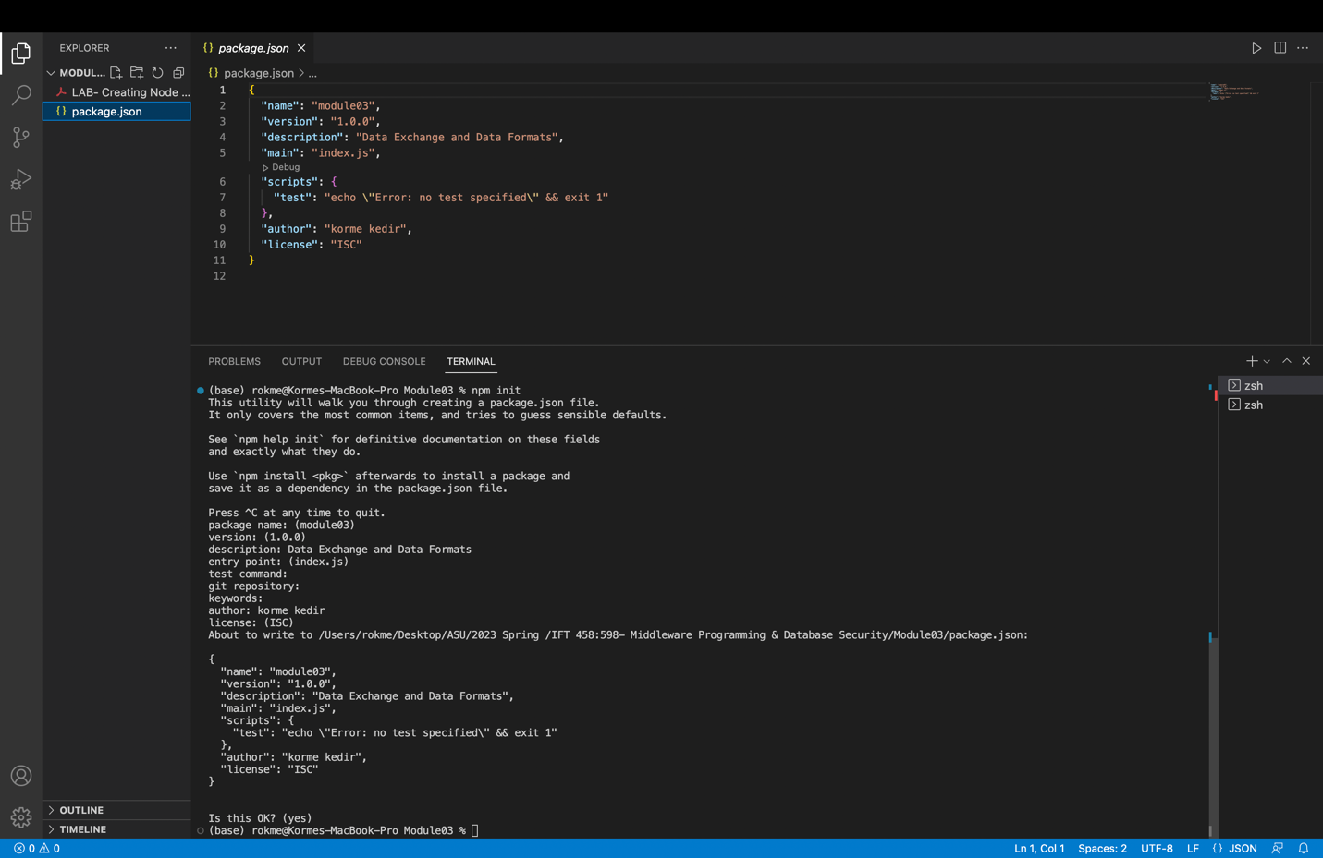

Reusable components to create a composite components:-1

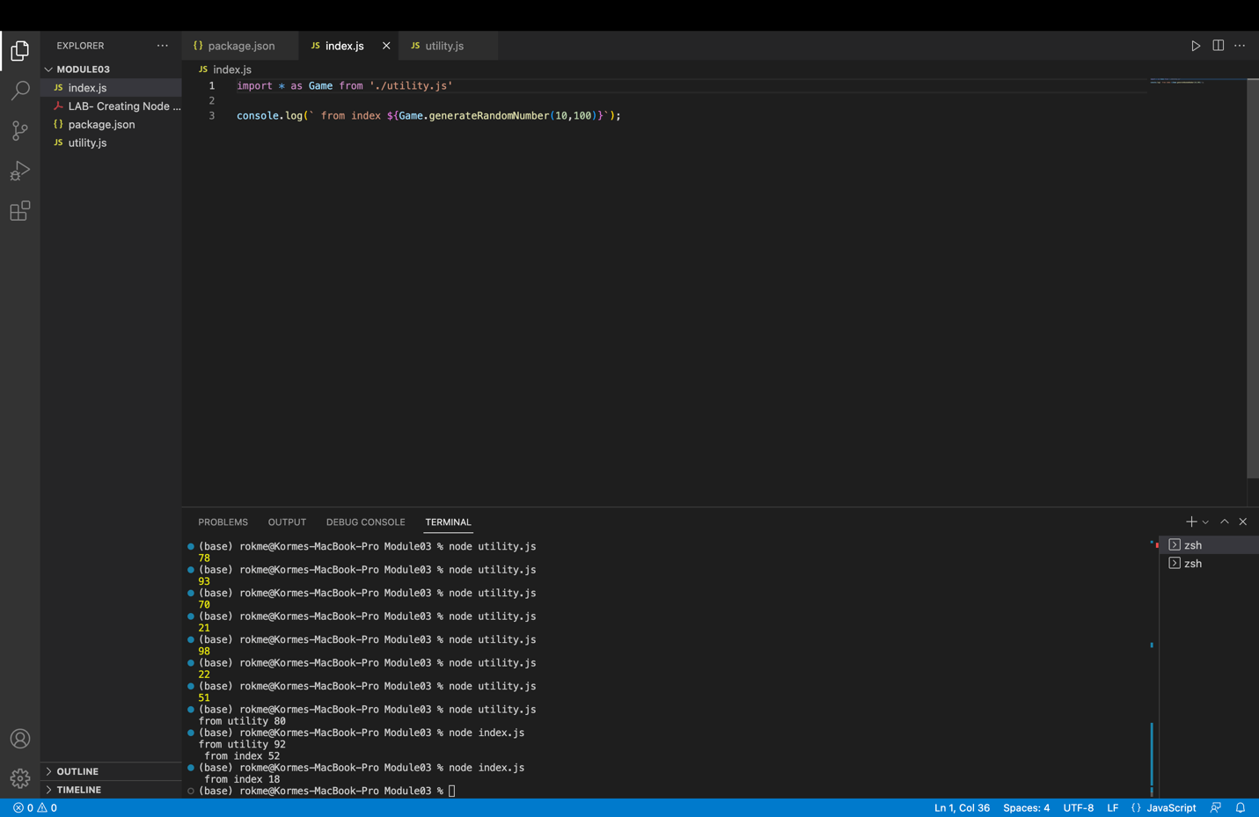

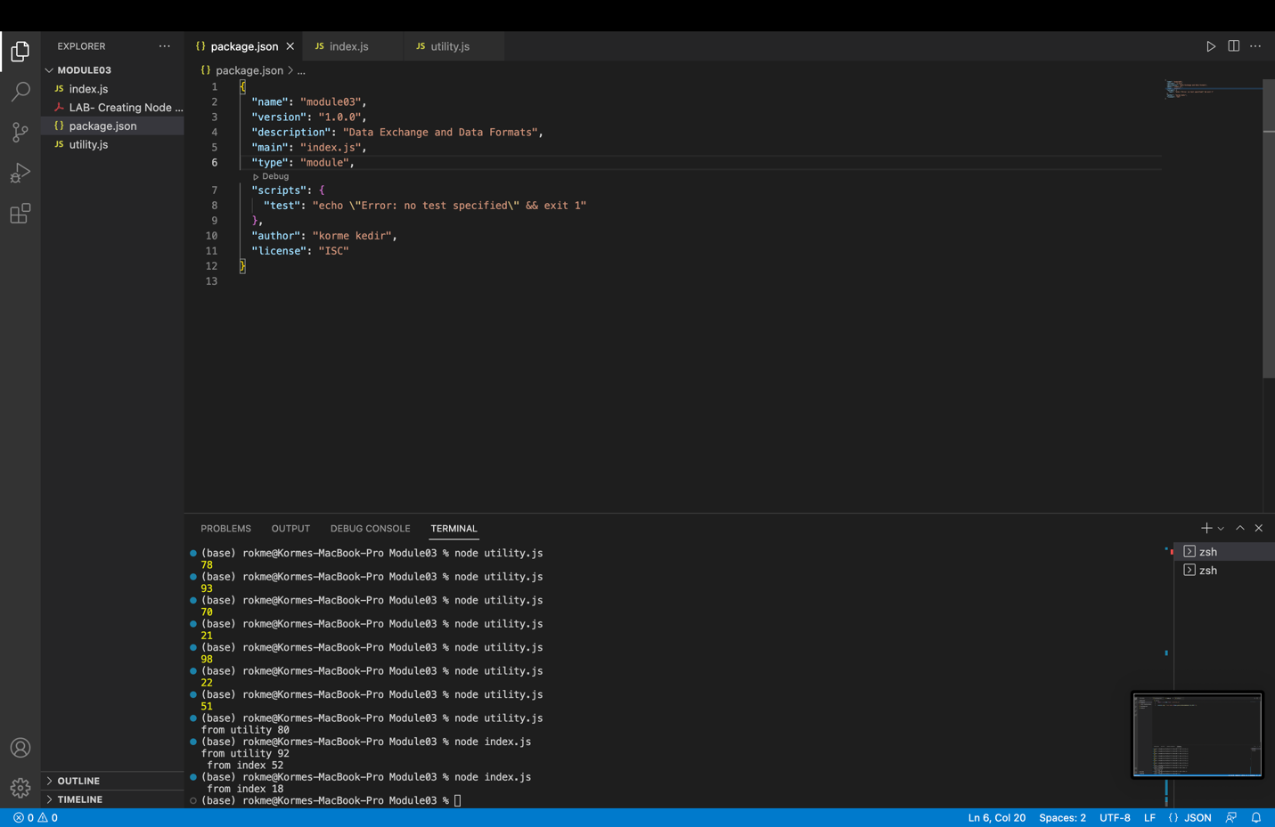

Using Importing External Modules (third-party modules).

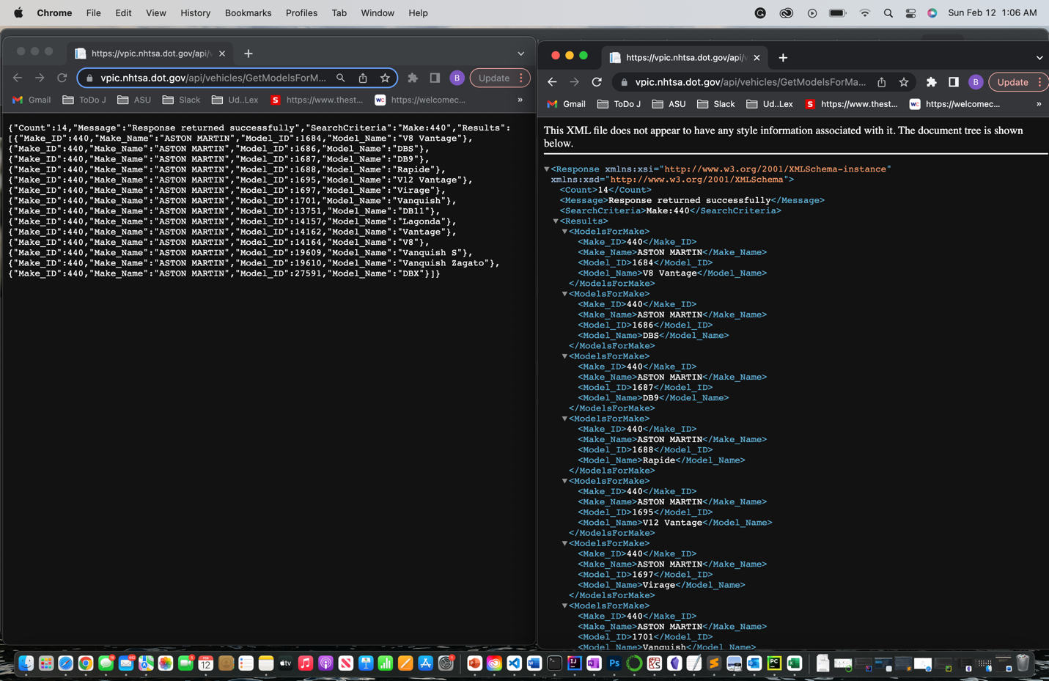

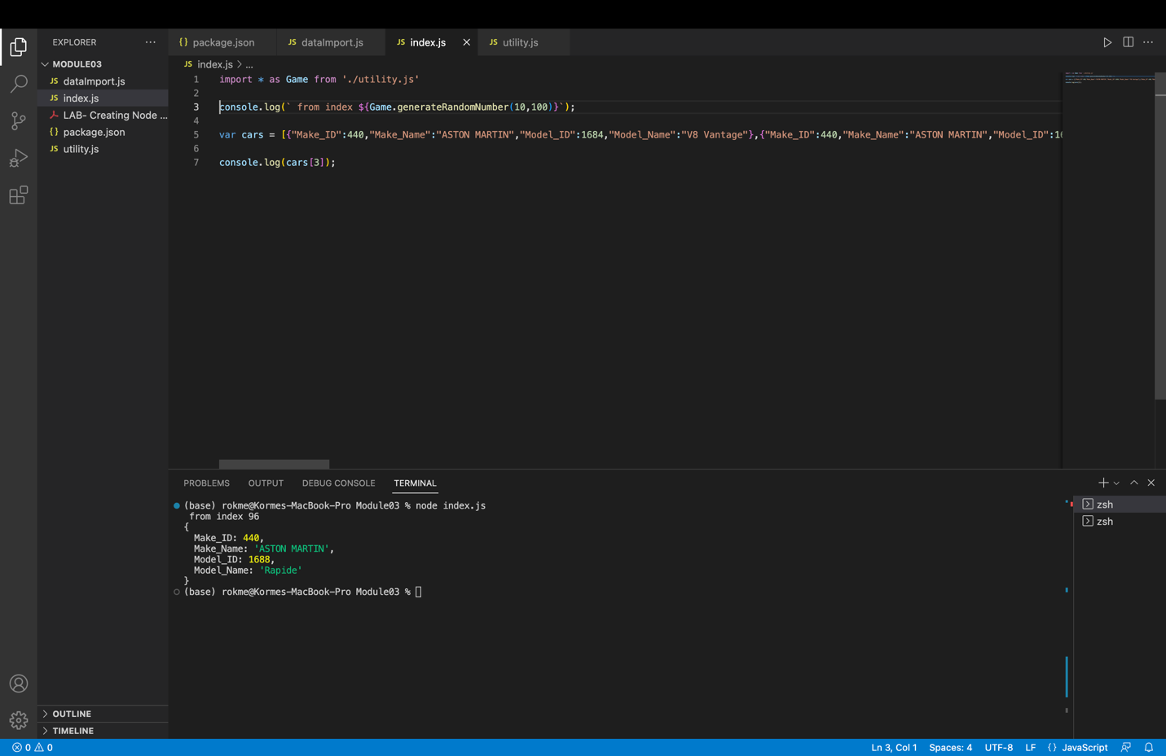

Data Formats and Data Exchange

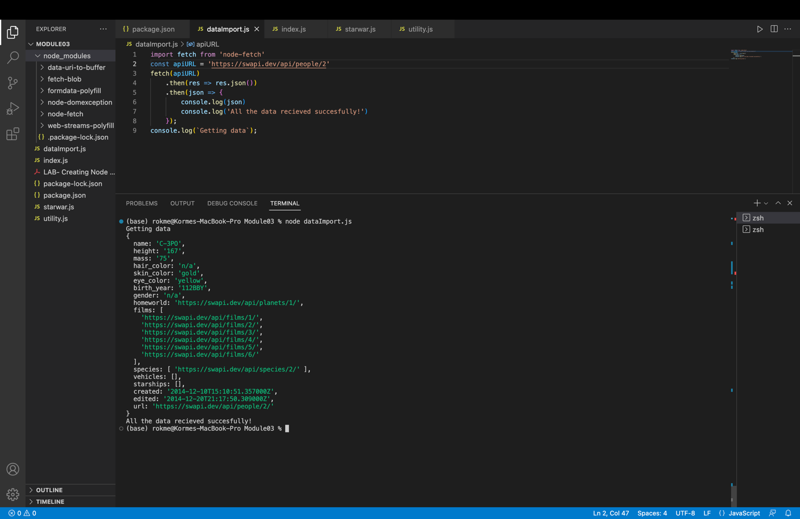

Content Negotiation

